North Lincolnshire Council
Daily Event Analysis
20th December 2010

Overview
On Monday 20th December eight of the eleven PM₁₀ air quality sites monitored by North Lincolnshire Council measured a mean PM₁₀ concentration above the 50μg/m³ allowed as a daily mean. These sites are plotted on the graph below. The highest mean PM₁₀ concentration was recorded at the Dawes Lane Coke oven Osiris measuring 77μg/m³. The Dawes Lane Osiris measured spikes in the morning which were not reflected at any station. The Low Santon TEOM also recorded higher points than other sites.

Site | Mean PM₁₀ Concentration (20.12.10)
Amvale | 75μg/m³
East Common Lane | 56μg/m³
North Lincs Santon Dawes Lane | 77μg/m³
Redbourn Club | 57μg/m³
Santon TEOM | 57μg/m³
Scunthorpe Town | 59μg/m³

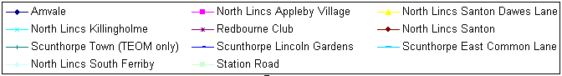

Met Conditions
A range of winds were measured throughout the day. Southerly winds were the most frequent. Wind speeds averaged at below 1m/s. Conditions during the Dawes Lane Osiris spikes demonstrated higher wind speeds at 1.3m/s and occurred during periods of consistent Southerly winds ranging between 170º & 190º. No rain was measured throughout the day. Ground conditions were similar to the 19th, snow and a hard frost covered all exposed locations.

Dawes Lane Coke Oven Spikes

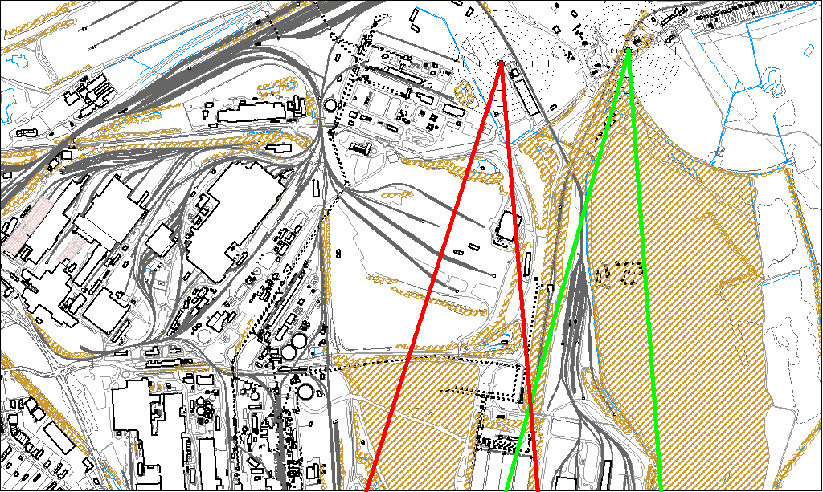

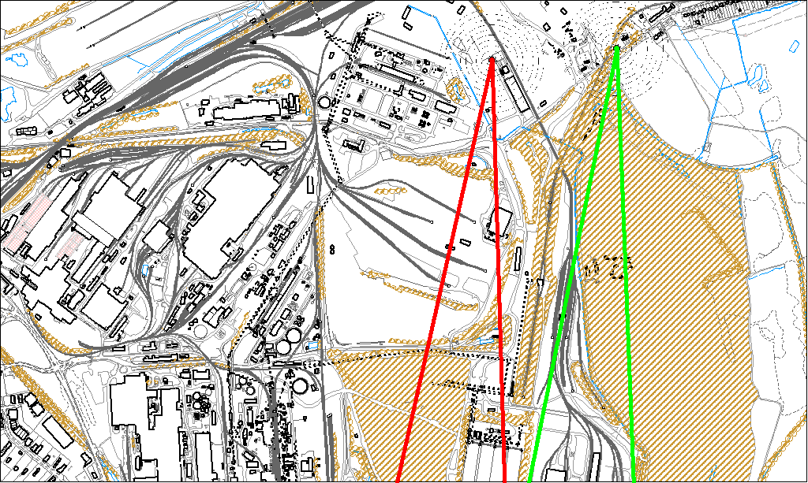

A comparison between the two spikes suggest the issue has resulted from a similar if not the same place. The wind speed and wind directions are identical during both periods. Shortly before the first Dawes Lane spike a comparable increase occurred at the Low Santon TEOM in which the wind was from a more South Westerly direction.

Due to the number of exceedances throughout the North Lincs network on the 20th December 2010 it is impossible to single out a source. The met conditions are similar to other exceedances within December leading to poor dispersion from other local sources such as stacks, traffic & domestic fuel use. The spikes at Dawes Lane most probably occurred because of single events. If, as with other reports, we assume that because the Low Santon TEOM did not experience the same levels during the same periods of time, it is unlikely to have originated from anywhere within that wind path (highlighted by the green lines). It’s most probable origin would be the wind sectors affecting the Dawes Lane Coke Oven Osiris (highlighted by the red lines) including;

- The Redbourn Site
- The Intermediate Site
- The Ore Beds

